**Assignment 2**

**Oliver Yuan, Ruyi Shi**

**Series 1**

**(p,d,q) = (1,0,0)**

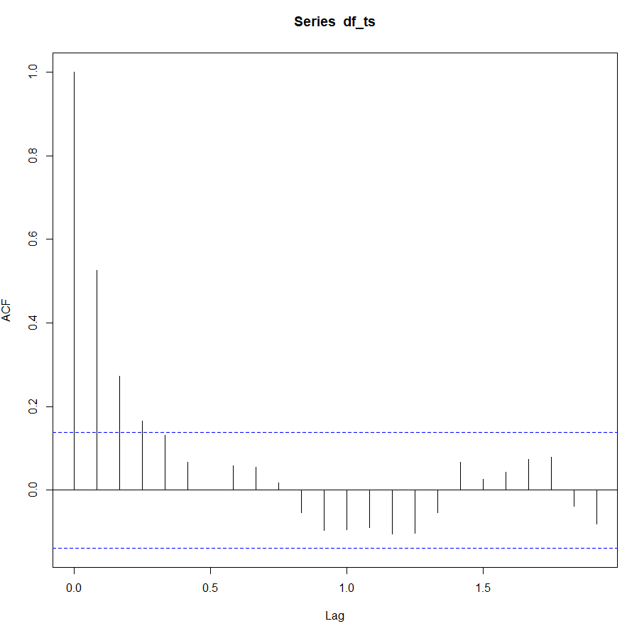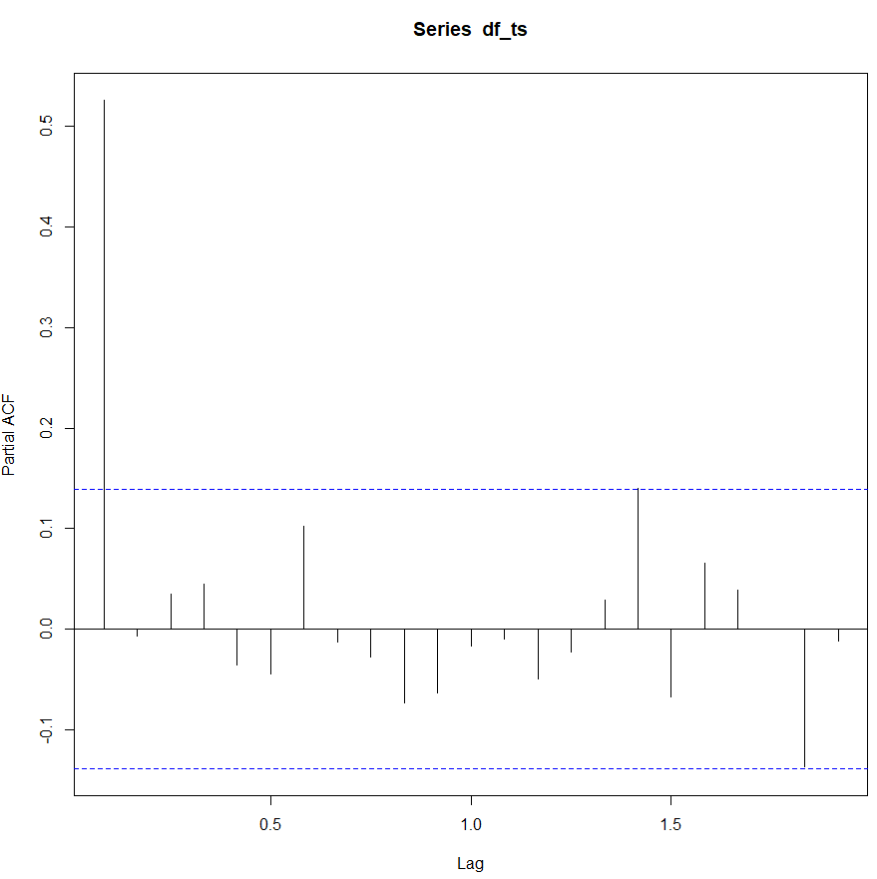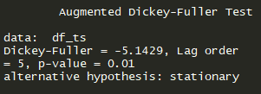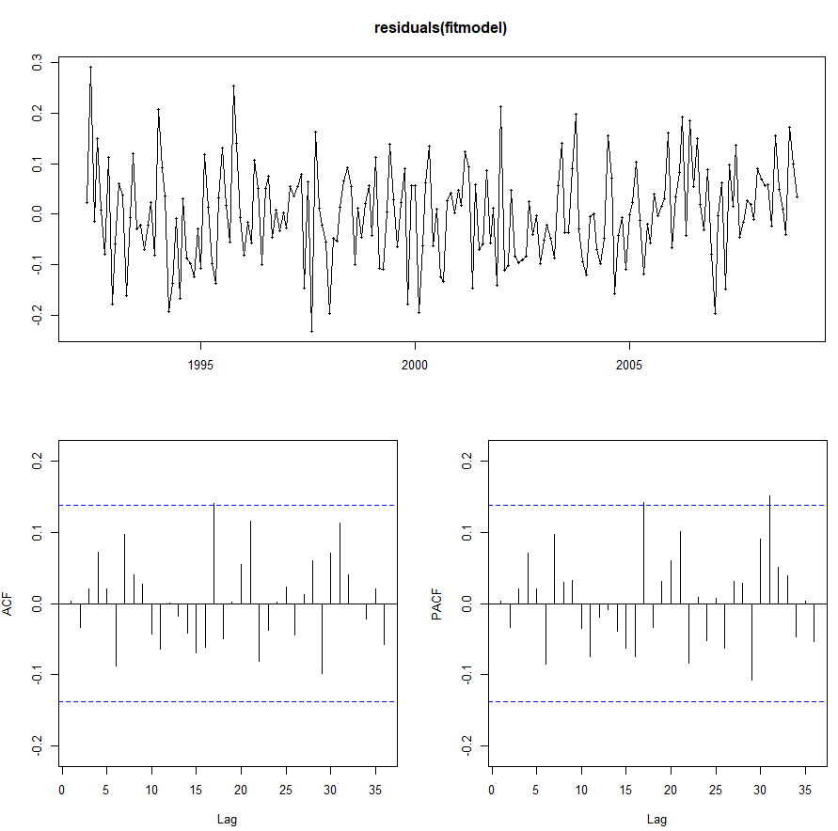

**Based on the ACF plot, PACF plot and Augmented Dickey-Fuller test, this series is stationary and AR(1) should be a good fit. The residual plot proved that.**

**Series 2**

**(p,d,q) = (2,1,1)**

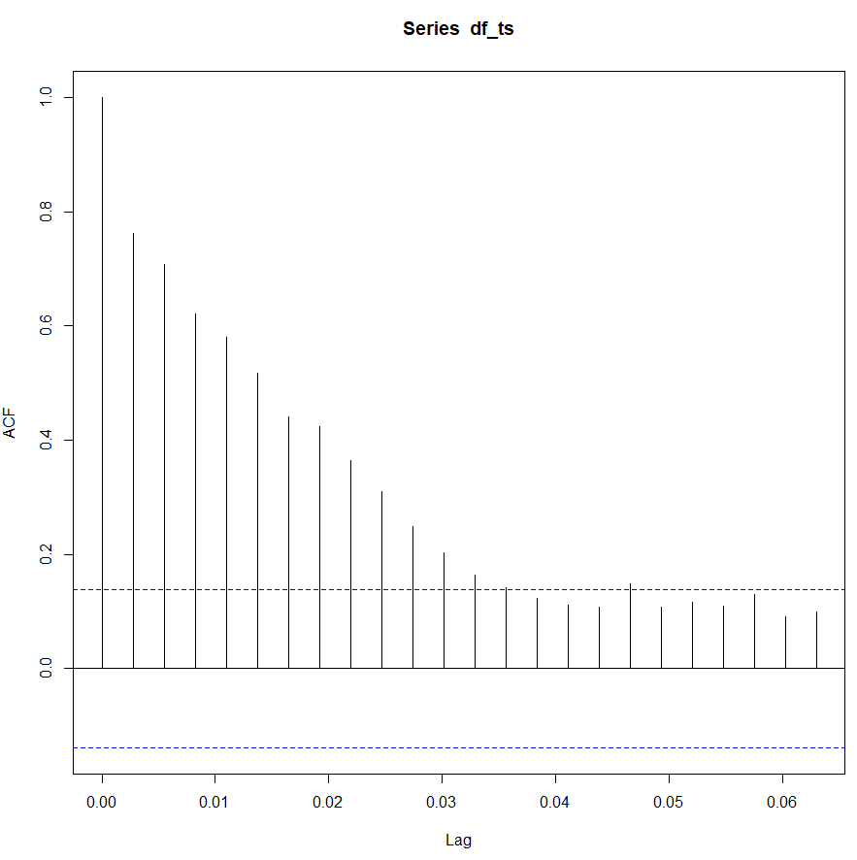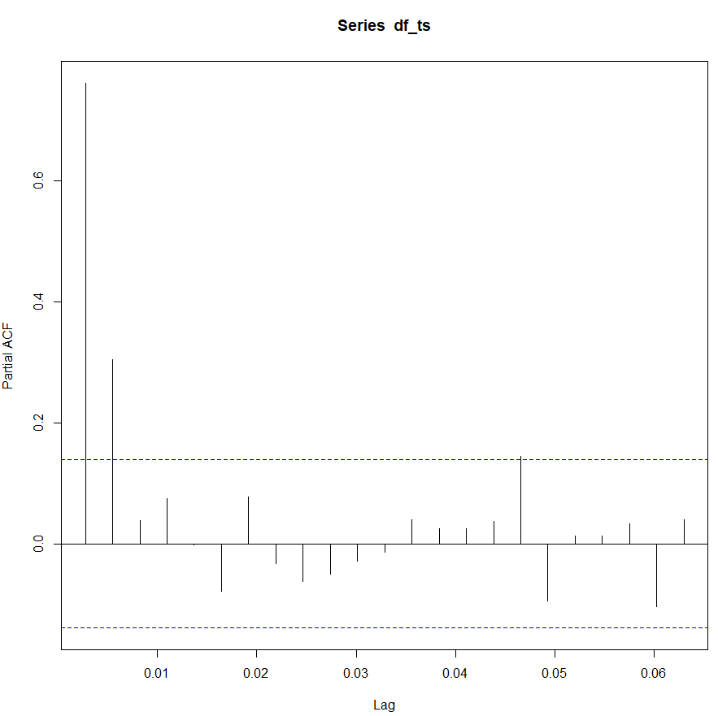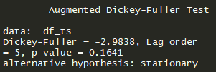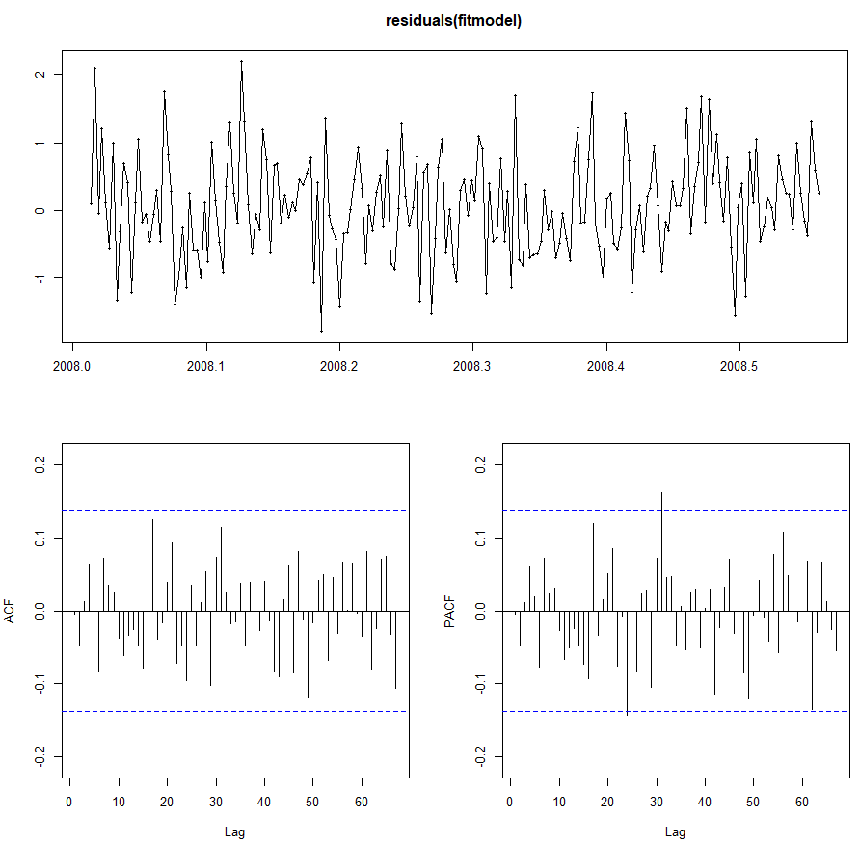

**Based on the ACF plot, PACF plot and Augmented Dickey-Fuller test, this series is not stationary so we took the first difference. And then we think AR(2) and MA(1) should be a good model. The residual plot proved that.**

**Series 3**

**(p,d,q) = (0,0,1)**

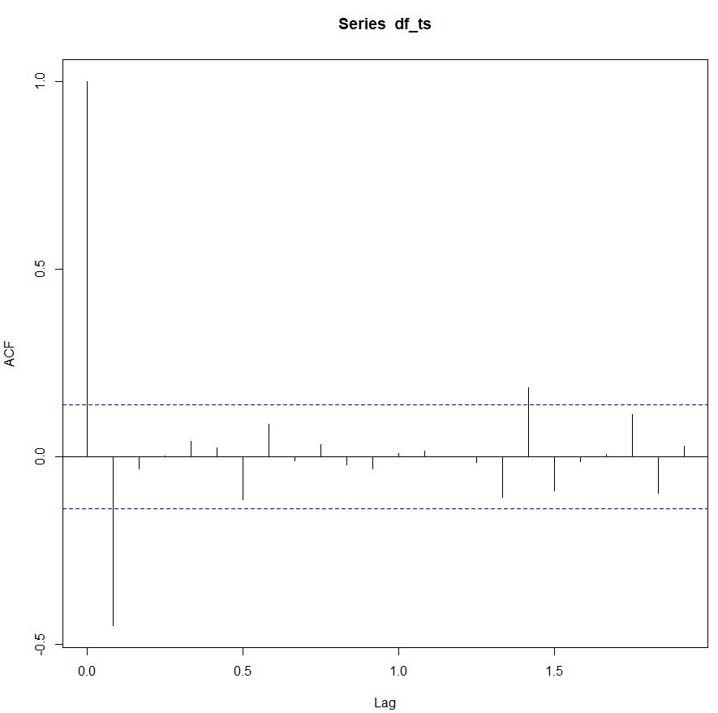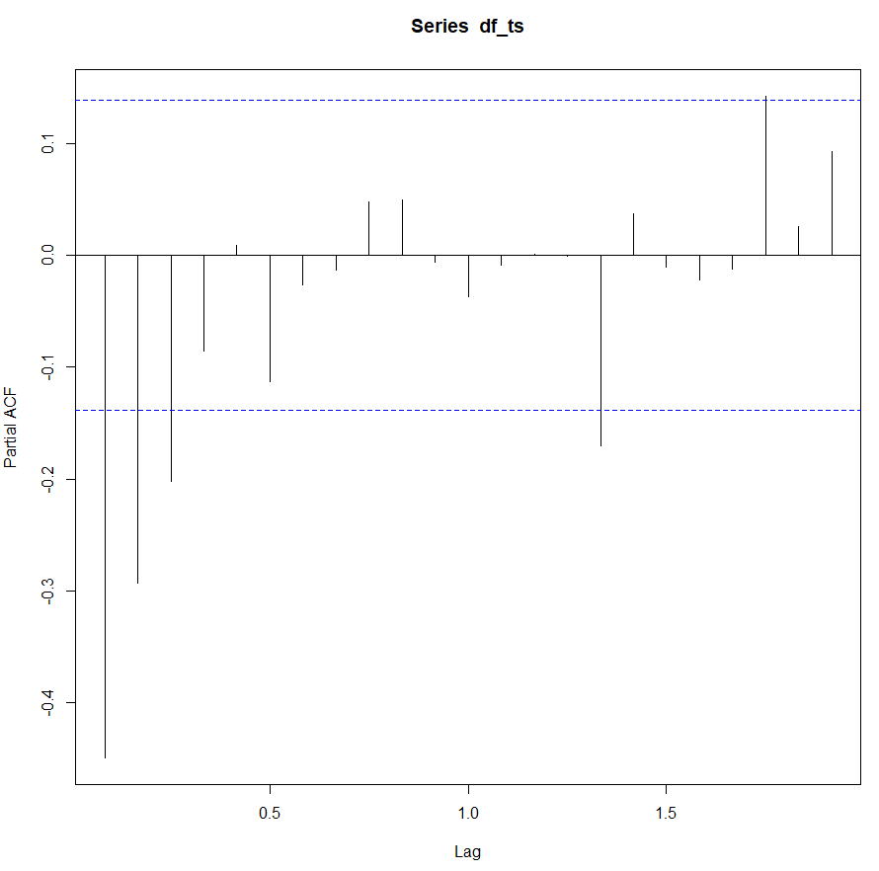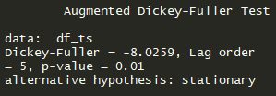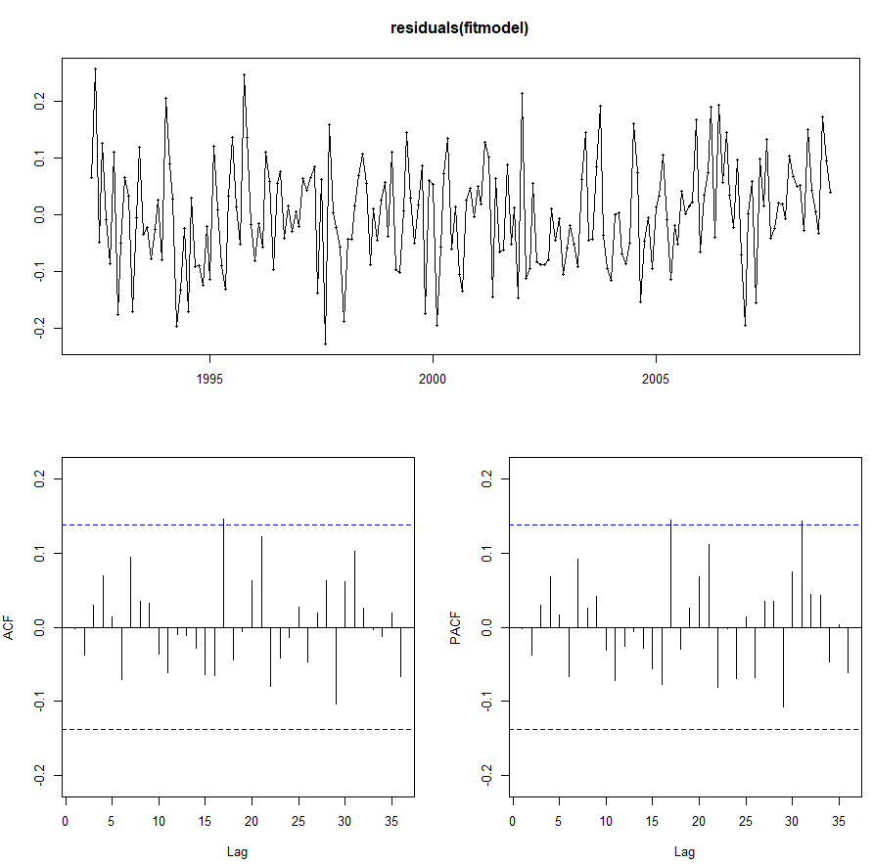

**Based on the ACF plot, PACF plot and Augmented Dickey-Fuller test, this series is stationary and MA(1) should be a good fit. The residual plot proved that.**

**Series 4**

**(p,d,q) = (2,0,3)**

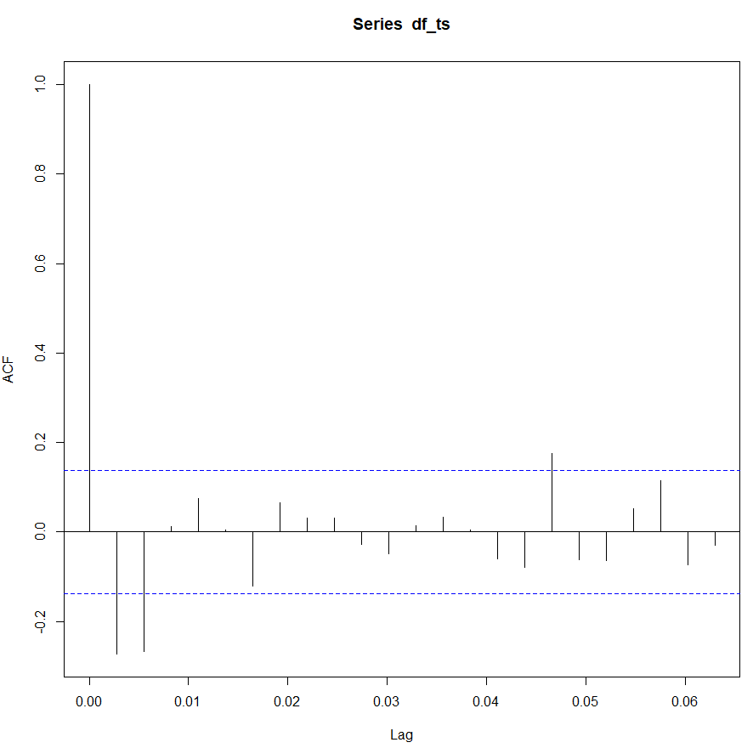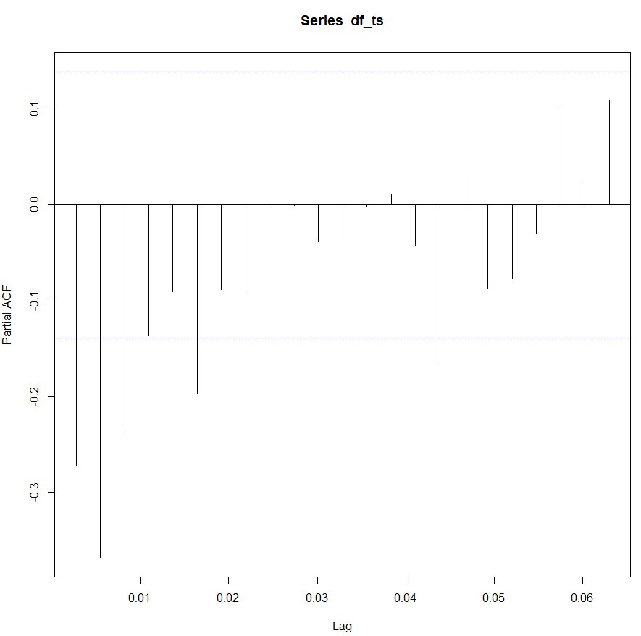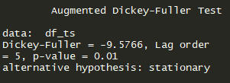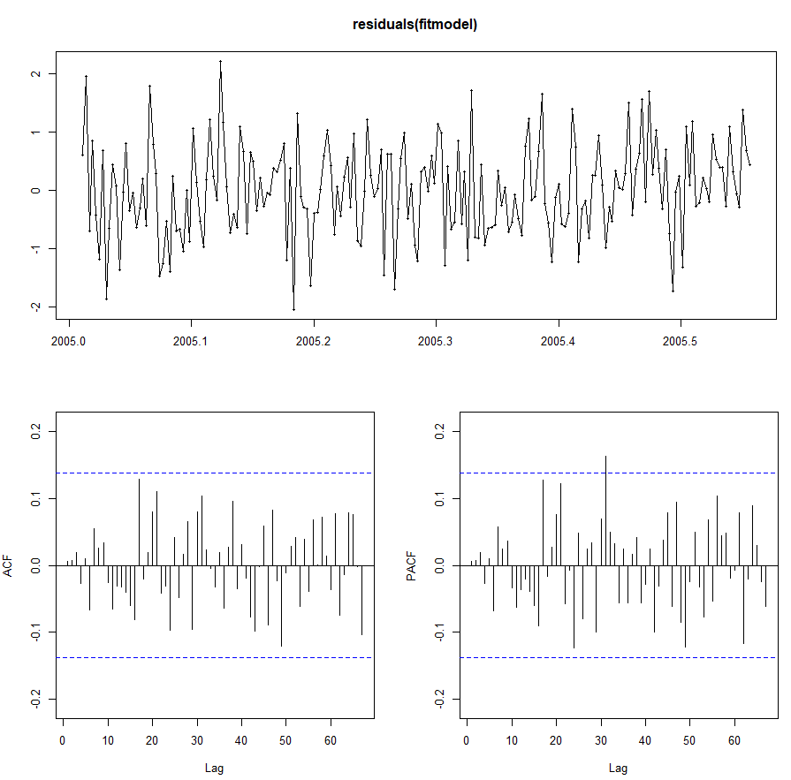

**Based on the ACF plot, PACF plot and Augmented Dickey-Fuller test, this series is stationary and AR(2) and MA(3) should be a good fit. The residual plot proved that.**

**Series 5**

**(p,d,q) = (1,0,2)**

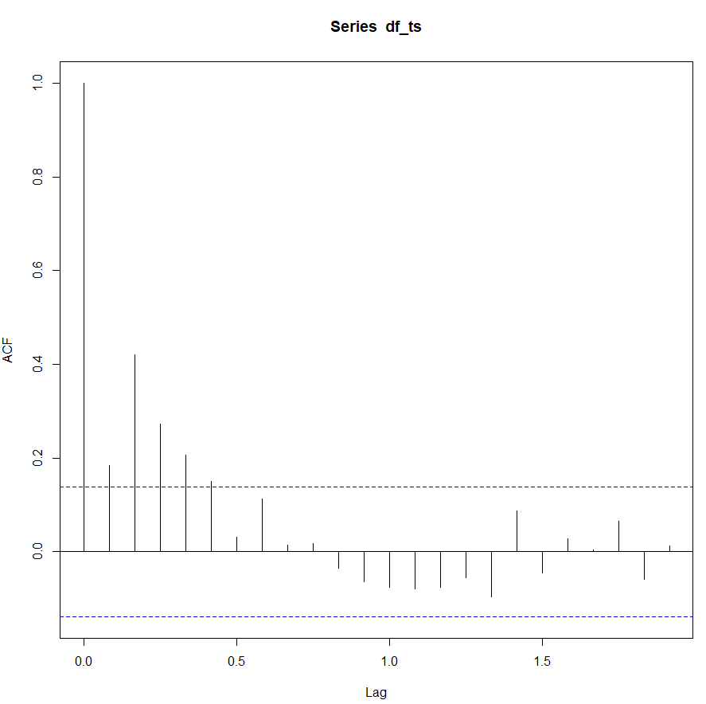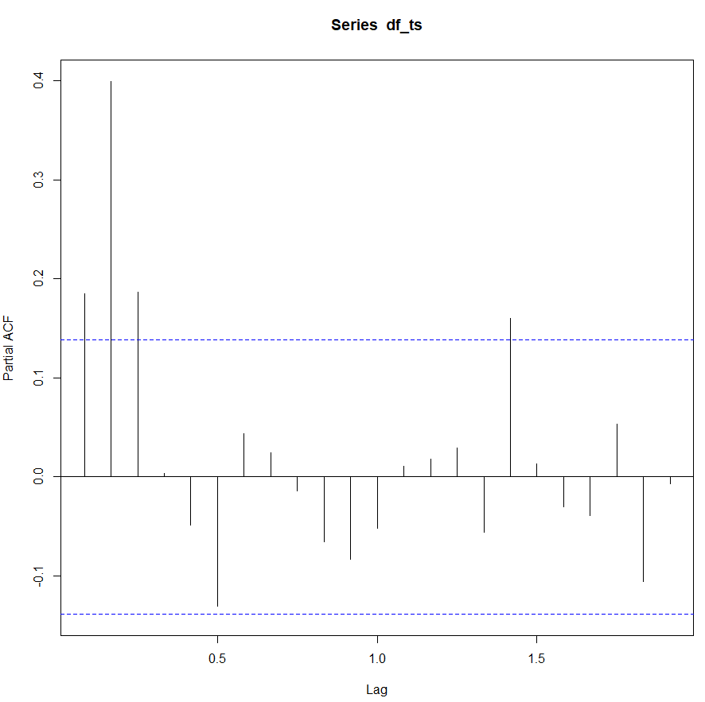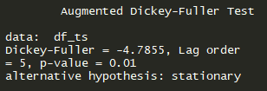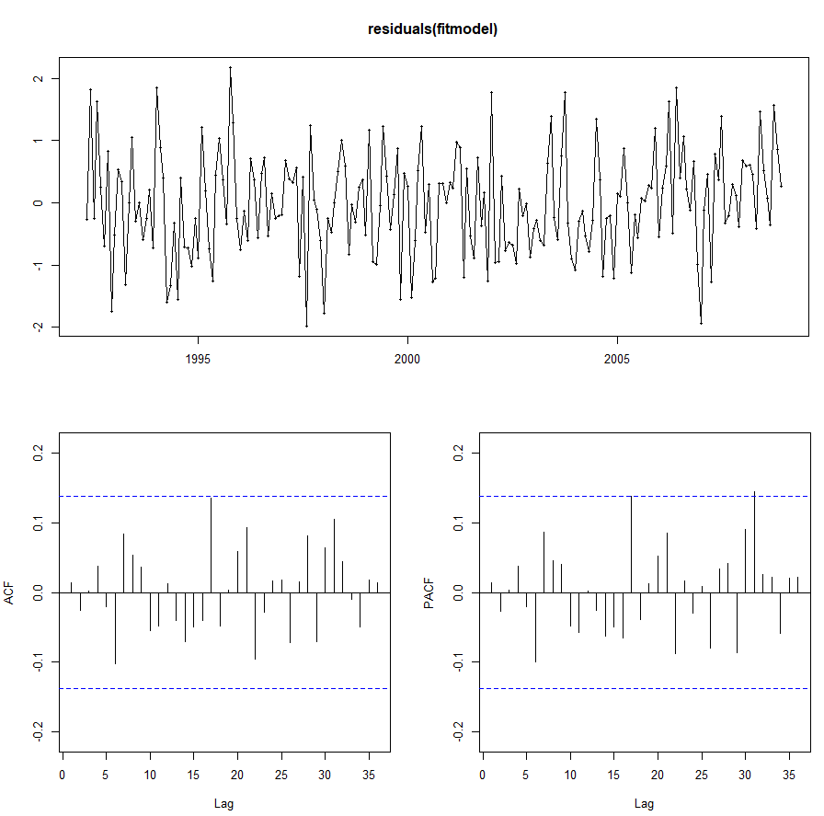

**Based on the ACF plot, PACF plot and Augmented Dickey-Fuller test, this series is stationary and AR(1) and MA(2) should be a good fit. The residual plot proved that.**

**Series 6**

**(p,d,q) = (2,0,1)**

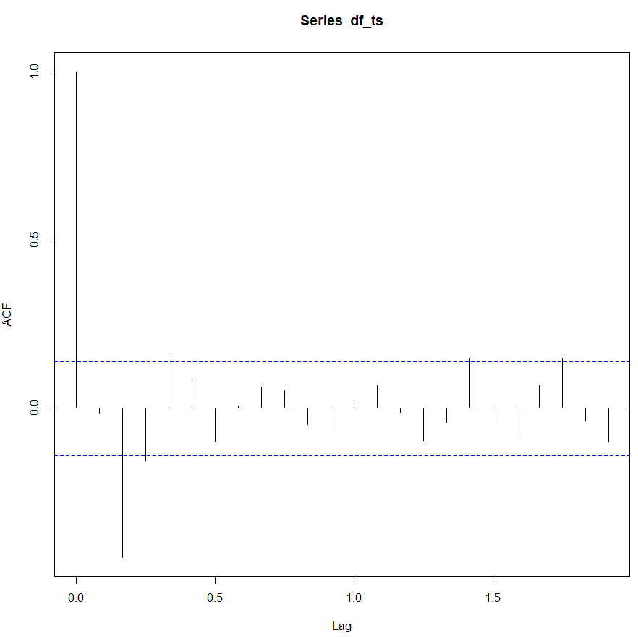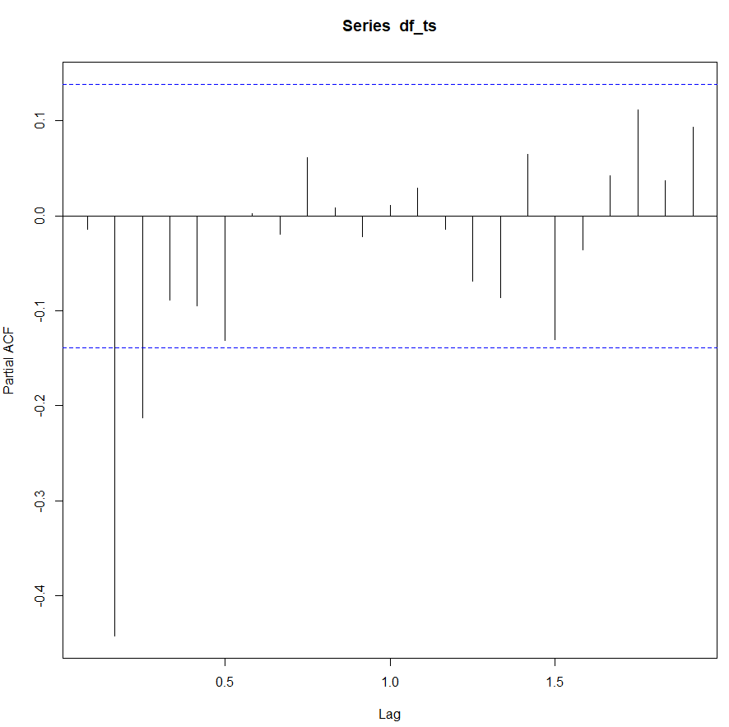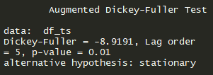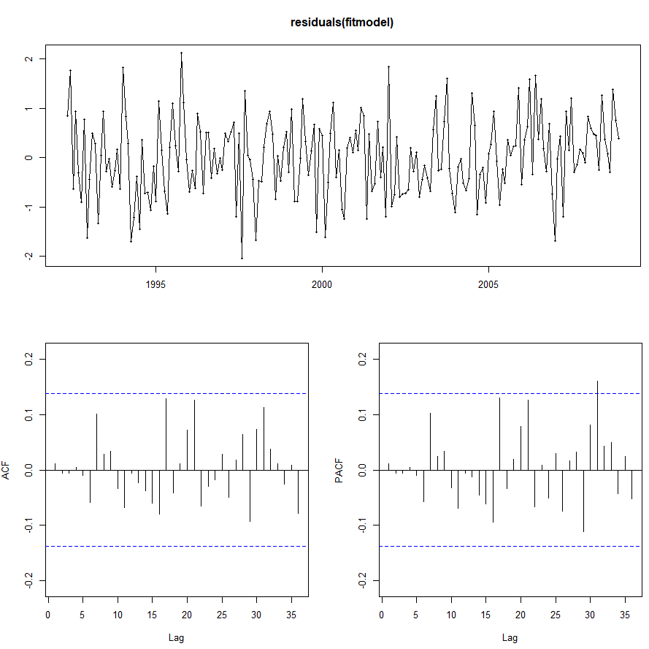

**Based on the ACF plot, PACF plot and Augmented Dickey-Fuller test, this series is stationary and AR(2) and MA(1) should be a good fit. The residual plot proved that.**

**Series 7**

**(p,d,q) = (0,1,2)**

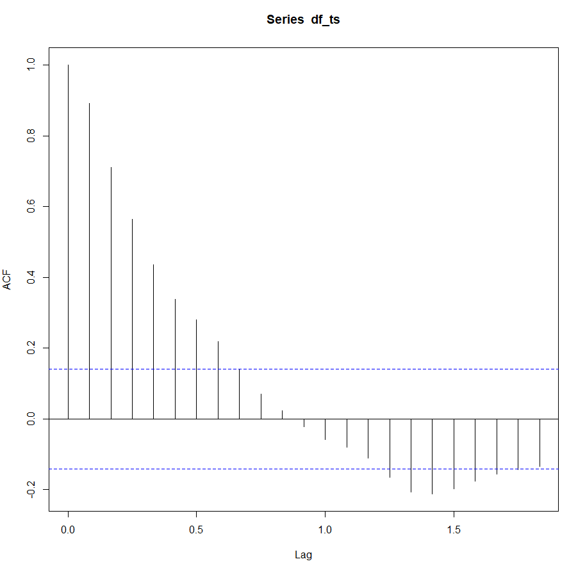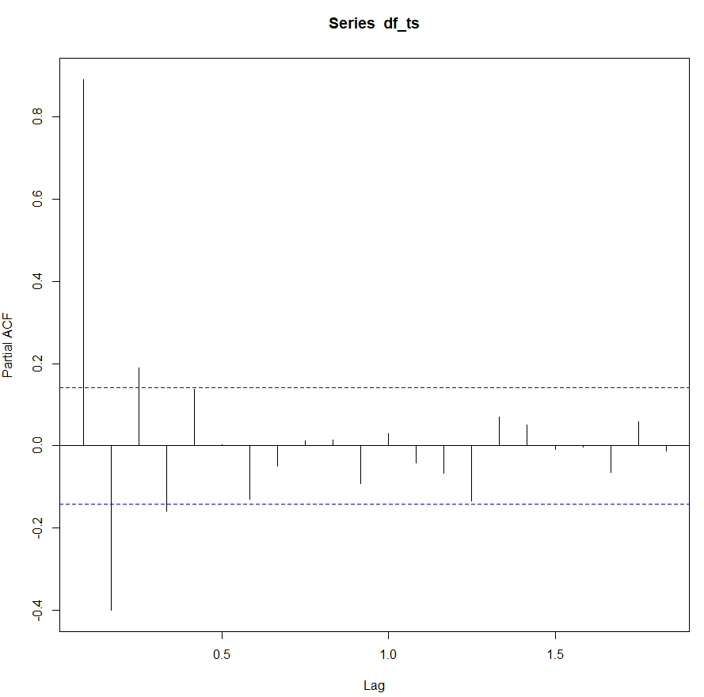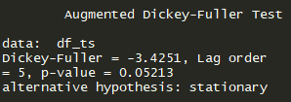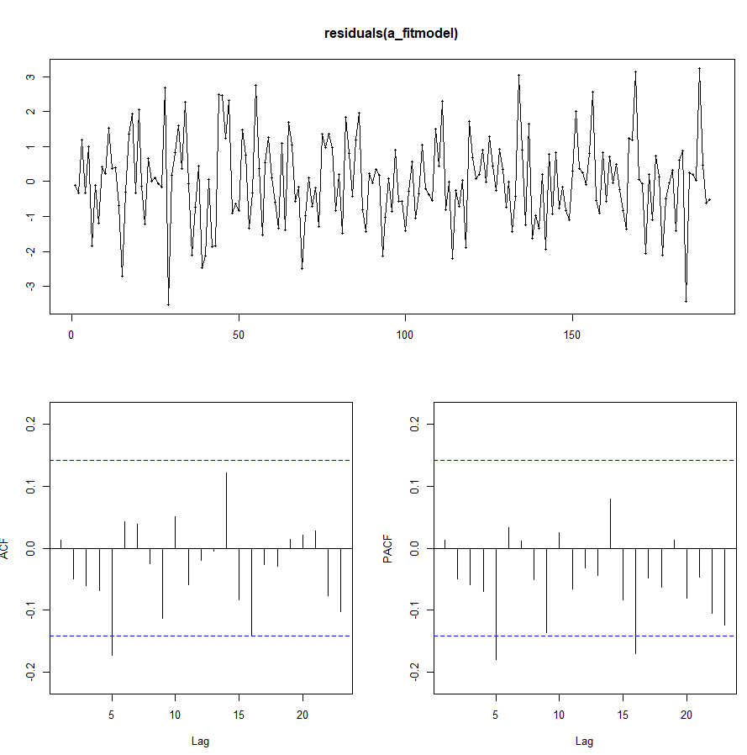

**Based on the ACF plot, PACF plot and Augmented Dickey-Fuller test, this series is not stationary so we took the first difference. And then we think MA(2) should be a good model. The residual plot proved that.**